Exercise 2-5 Feature Overview

Jirayu Petchhan, D10907801

Editing code part

if __name__=='__main__':

# get class

c = {}

with open("imagenet1000_clsidx_to_labels.txt") as f:

for line in f:

(key, val) = line.split(":")

c[int(key)] = val.split(",")[0]

# Define image path and select the layer

myClass=FeatureVisualization('./Front_Boat.jpg',2)

Compare=FeatureVisualization('./Rear_Truck.jpg',2)

print(myClass.pretrained_model2)

myClass.save_feature_to_img()

print("The first picture classification predict:")

myClass_vector = myClass.predict()

print("The second picture classification predict:")

Compare_vector = Compare.predict()

#Define cosine similarity

cos= nn.CosineSimilarity(dim=1)

#Define Euclidean distance

euclidean_dist = torch.dist(myClass_vector,Compare_vector,p=2)

cosine_dist = cos(myClass_vector,Compare_vector)

print("Verification:")

if cosine_dist > 0.4:

print("They are the same!")

print("Their cosine_similarity:{}".format(cosine_dist))

else:

print("They are not the same!")

print("Their cosine_similarity:{}".format(cosine_dist))

print("Their euclidean_dist:{}".format(euclidean_dist))

Code Display

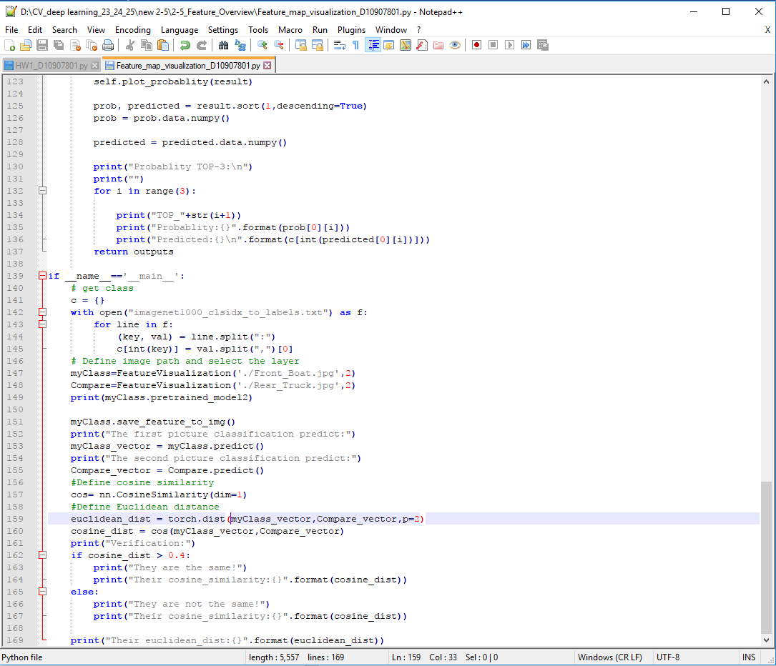

Training

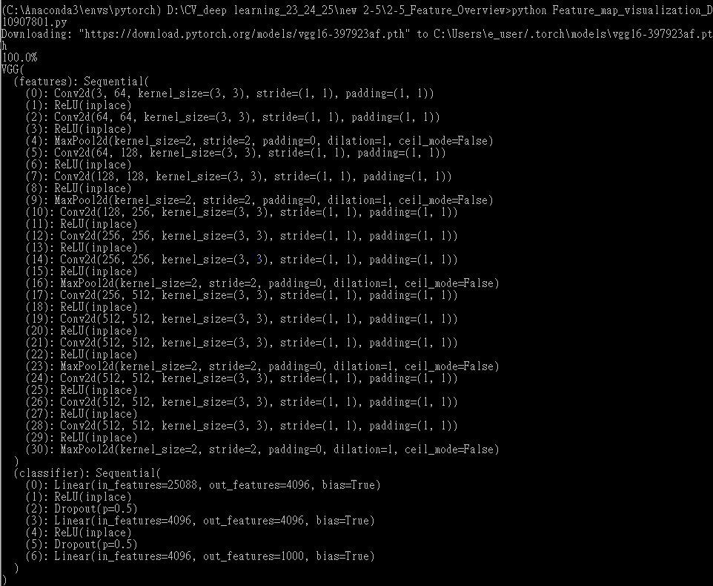

Result of Boat Pic (1st pic)

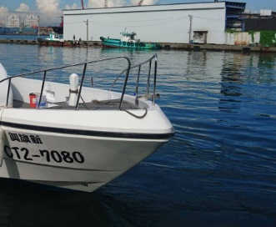

Real Image

Result of visualization

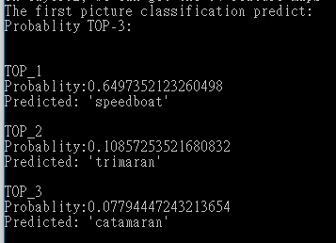

Speedboat is predicted by 64.9 % in the Top 1

Result of Truck Pic (2nd pic)

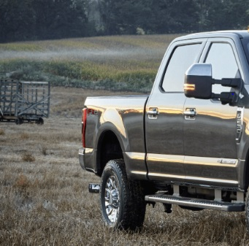

Real Image

Result of visualization

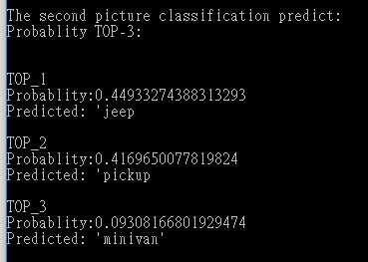

Jeep is predicted by 44.9 % in the Top 1

Pickup is predicted by 41.70% in the Top 2

Verification

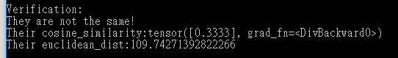

The result is shown that 2 pics are not the same.